Kirchhoff’s Laws

Name: _____________________

Objective
To understand Kirchhoff’s circuit rules and use them to determine the currents that flow in various parts of DC circuits.

Overview
Consider a circuit that has many components wired together in a complex array. Suppose you want to calculate the currents in various branches of this circuit. The rules for combining resistors are convenient in circuits made up only of resistors that are connected in series or in parallel. While it may be possible in some cases to simplify parts of a circuit with the series and parallel rules, complete simplification to an equivalent resistance is often impossible. The application of Kirchhoff’s rules can help us to understand complex circuits with more than one battery.
Kirchhoff circuit rules applied to circuits are based on two conservation laws – conservation of energy and conservation of charge. To analyze the circuits, we define few terms:
- Branch: A branch is a portion of the circuit in which the current is the same through all the circuit elements.
- Junction or Node: A junction in a circuit is a place where two or more wires are connected. It is the point of connection between two or more branches.
- Loop: A loop is any closed path in a circuit.

Kirchhoff’s rules:
- Junction Rule: The sum of the currents entering a junction equals the sum of the currents leaving out of the same junction. Junction rules is based on charge conservation.
- Loop Rule: The sum of the changes in electric potential around a closed loop is zero.

Let us consider the circuit shown below.
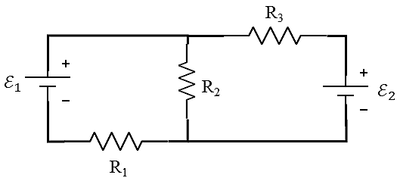
Question 1-1: How many unknown currents are flowing in the circuit?
Question 1-2: Mark Junction (or Junctions) on the figure.
We will use PHET simulation Circuit Construction Kit: DC - Virtual Lab (https://phet.colorado.edu/en/simulation/circuit-construction-kit-dc-virtual-lab)
- Open the PHET simulation Circuit Construction Kit: DC - Virtual Lab
- Set-up the circuit shown in the above figure.
- Set the resistances values: R₁ = 75 Ω, R₂ = 40 Ω, and R₃ = 100 Ω. Click on the resistor; you will be able to see the value of resistance and then change it using the slider switch.
- Choose the following battery voltages: $ℇ_{1}=10 V and ℇ_{2}=25 V$
Take a screenshot after you connect the circuit and paste it.
e
d
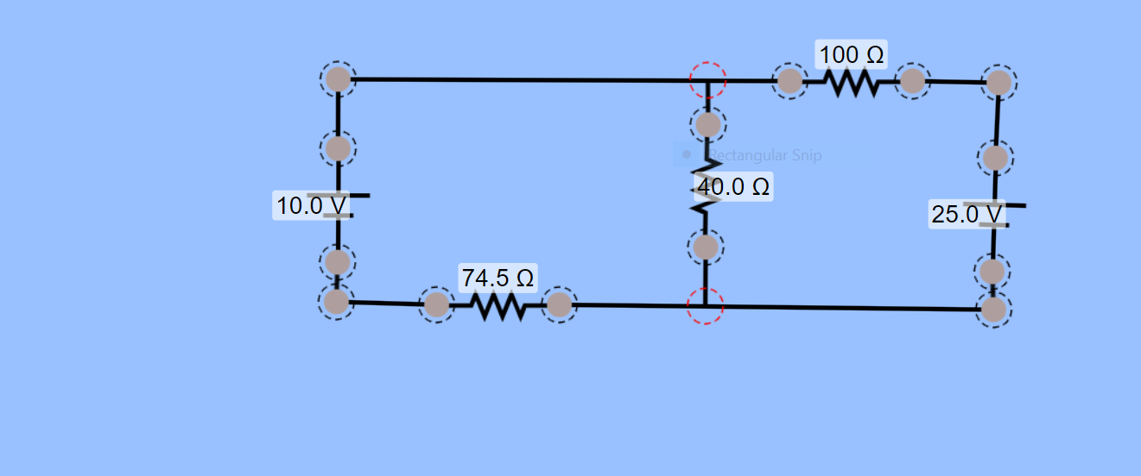
h
g
f
a
c
b
Question 1-3: Apply Junction rule to one of the junctions. Do you get a different equation when you apply the rule to the other junction?
Equation 1: when I apply the junction rule in the middle junction, I get the equation:
I₁ = I₂ + I₃
Applying in different junctions give the same equation no new information being provided. This is a single equation with three unknowns—three independent equations are needed, and so the loop rule must be applied.
Question 1-4: Assuming that the internal resistances of the batteries are negligible, apply loop rule to any two closed loops. Write down the equations for each loop.
Equation 2: consider the loop abcdea. Going from a to c, we traverse from – to + so that the change in potential is +emf2. Then from c to d which is in the same (assumed) direction of the current I3 the resistor 3 so that the change in potential is –I3R3. Completing the loop by going from d to a again traverses a resistor in the same direction as its current, giving a change in potential of –I2R2. The loop rule states that the changes in potential sum to zero. Thus, +emf2 – I3R3 – I2R2 = 0
Substituting values from the circuit diagram for the resistances and emf gives:
25 – 100R3 – 40 R2 = 0

Equation 3:
Considering the loop rule to aefgha similarly gives:
+I2R2 –emf1 + I1R1 = 0
40I2 – 10 + 75I1 = 0

- Solve these three equations for the three unknown currents, I₁, I₂, and I₃ in amperes. Show your calculations below.
The three equations are:
I₁ = I₂ + I₃
25 – 100I3 – 40 I2 = 0
40I2 – 10 + 75I1 = 0

I3 = 0.25 – 0.4I2
I1 = 0.133 – 0.533 I2
Substituting these two equations in equation 1,
I₁ = I₂ + I₃
0.133 – 0.533 I2 = I2 + 0.25 – 0.4I2
0.133 – 0.25 = I2 – 0.4I2 + 0.533 I2
-0.117 = 1.133I2
I2 = -0.103 A
I3 = 0.25 – 0.4 (-0.103) = 0.291 A
I1 = 0.133 – 0.533(-0.103) = 0.188 A
- Modify the circuit to measure currents flowing through each resistor. You must use ammeter to measure current.
- Take a screenshot after you connect ammeters in the circuit and paste it below.
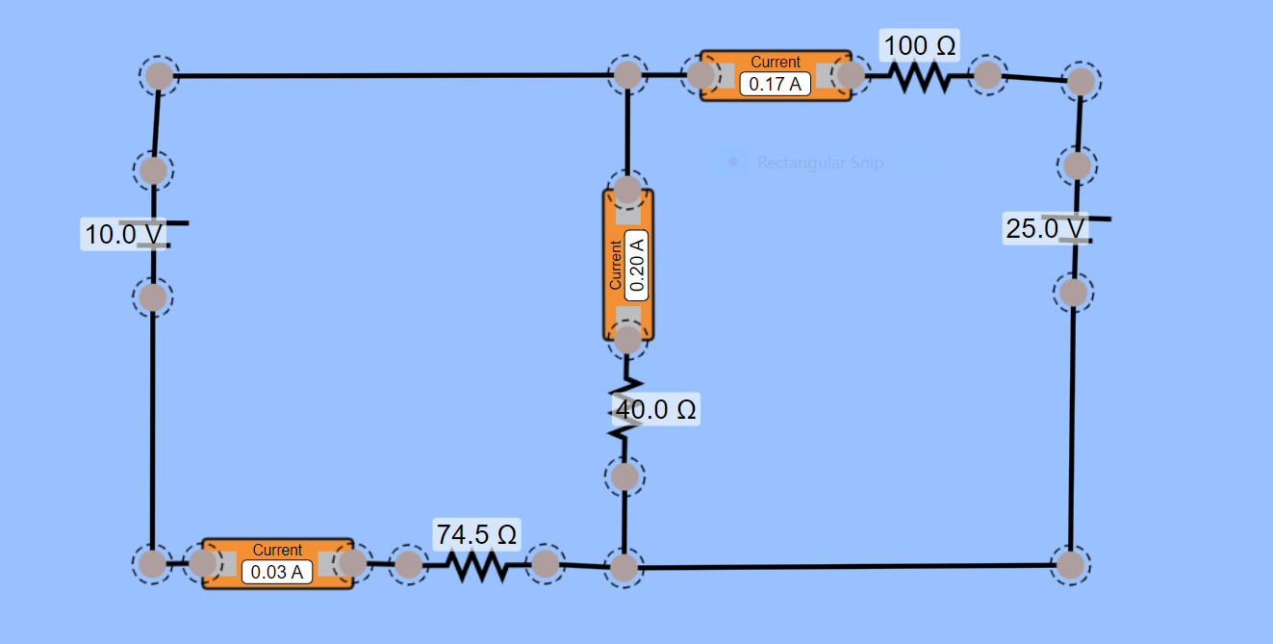
- Vary the battery emf${ E}_{1}$ and complete the table below:
Calculate the currents flowing through each resistor using Ohm’s law, V = IR

$${ E}_{1}$$  (V) | $${ E}_{2}$$  (V) | V₁  (V) | V₂  (V) | V₃  (V) | I₁  (A) | I₂  (A) | I₃  (A) | I₁ (calculated) | I₂ (calculated) | I₃  (calculated)
10 | 25 | 15 | 1.2 | 17 | 0.20 | 0.03 | 0.17 | 0.19 | -0.103 | 0.291
15 | 25 | 17.25 | 3.2 | 16 | 0.23 | 0.08 | 0.16 | 0.224 | -0.044 | 0.268
20 | 25 | 20.25 | 4.8 | 14 | 0.27 | 0.12 | 0.14 | 0.27 | 0.13 | 0.14
25 | 25 | 22.5 | 6.8 | 13 | 0.30 | 0.17 | 0.13 | 0.29 | 0.16 | 0.13
30 | 25 | 25.5 | 8.8 | 12 | 0.34 | 0.22 | 0.12 | 0.34 | 0.23 | 0.11

Question 1-5: Did your measured currents match with the calculated current values?
My measured currents were comparable to the calculated values.
Question 1-6: Use your measured current values to verify the junction rule at the junction in the circuit. Show one calculation.
I₁ = I₂ + I₃
When ${ E}_{1}$ is 10.0 V and ${ E}_{2}$ is 25.0 V the measured I1 is 0.20 A while I2 = 0.03 A and I3 = 0.17 A
0.03 + 0.17 = 0.20 A. Therefore, the measured current values verify the junction rule.

Question 1-7: Use your measured voltage values to verify the loop rule in the left loop of the circuit. Show one calculation.
Loop Rule: The sum of the changes in electric potential around a closed loop is zero.
The left loop is aefgha whose equation is +I2R2 –emf1 + I1R1 = 0
This equation is satisfied using the values of the measured voltage.
Question 1-8: Why aren’t the resistors R₁ and R₂ in series? Why aren’t they in parallel?
When resistors are connected in parallel, more current flows from the source than would flow for any of them individually, so the total resistance is lower. Less current is flowing in both resistor 1 and 2 and therefore they are in series.
- Now consider the case where resistor R₂ is removed from the circuit. Take a screenshot after you have made the changes.
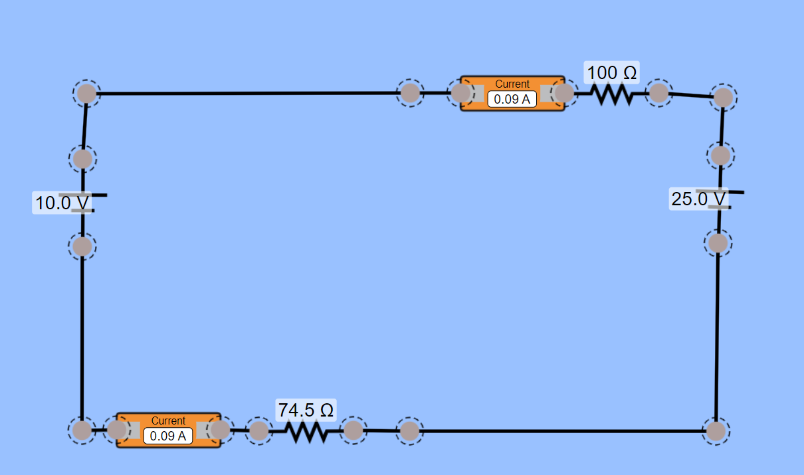
Question 1-9: Will you need to generate more or fewer equations with Kirchhoff’s loop rule? With Kirchhoff’s Junction rule? Why?
Fewer equations will be generated in both junction and loop rule. This is because the number of unknown Is will reduce to two.
Question 1-10: What is the effective value of R₂ in the modified circuit?
In the modified circuit, R₂ will be R = V/I
= 25/0.09
= 278 Ω

